**Logic gate**

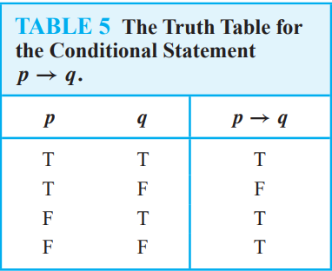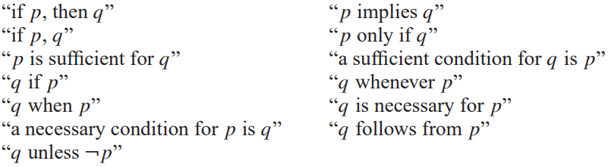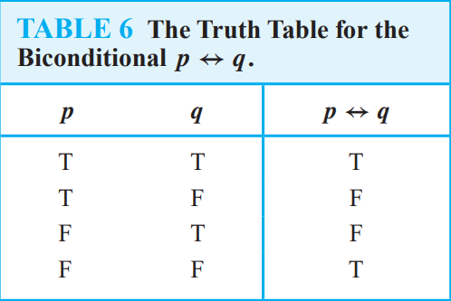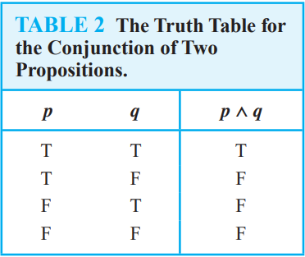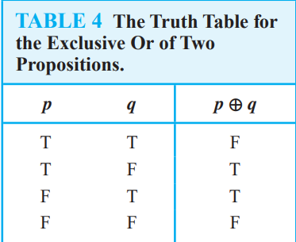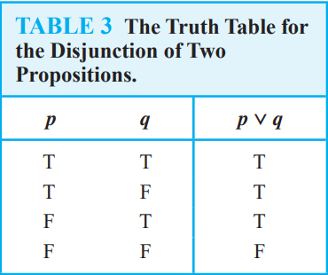

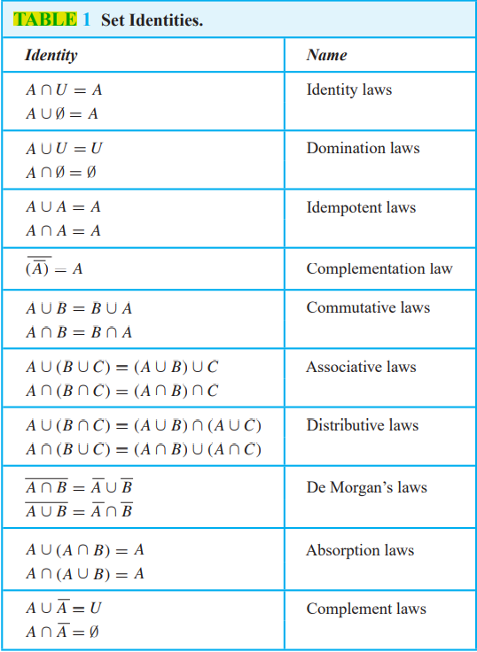

Focus on **De Morgan’s Laws**

**One-to-one and Onto table**

|  |  |  |
| --- | --- | --- |
| F1 | One-to-One? | Onto? |
| F1(n) = n2 | Yes | No |
| F2(n) = n/2 | Yes | No |
| F3(n) = [√n] | No | Yes |
| F4(n) = n – 1, 0dd n  = n + 1, even n | Yes | Yes |

(prolly wont came out) check <https://www.cs.colorado.edu/~srirams/courses/csci2824-spr14/functionTypes-18.html>

|  |  |  |  |  |
| --- | --- | --- | --- | --- |
| **Gate Logic** | | | | |
| [**Buffer**](https://en.wikipedia.org/wiki/Buffer_gate) | [NOT symbol](https://en.wikipedia.org/wiki/File:Buffer_ANSI_Labelled.svg) | [NOT symbol](https://en.wikipedia.org/wiki/File:Buffer_IEC_Labelled.svg) | {\displaystyle {A}} | |  |  | | --- | --- | | **INPUT** | **OUTPUT** | | A | Q | | 0 | 0 | | 1 | 1 | |
| [**NOT**](https://en.wikipedia.org/wiki/NOT_gate) (inverter) | [NOT symbol](https://en.wikipedia.org/wiki/File:NOT_ANSI_Labelled.svg) | [NOT symbol](https://en.wikipedia.org/wiki/File:NOT_IEC_Labelled.svg) | {\displaystyle {\overline {A}}} or {\displaystyle \neg A} | |  |  | | --- | --- | | **INPUT** | **OUTPUT** | | A | Q | | 0 | 1 | | 1 | 0 | |

|  |  |  |  |  |  |  |  |  |  |  |  |  |  |  |  |  |  |  |  |  |  |  |
| --- | --- | --- | --- | --- | --- | --- | --- | --- | --- | --- | --- | --- | --- | --- | --- | --- | --- | --- | --- | --- | --- | --- |
| [**XOR**](https://en.wikipedia.org/wiki/XOR_gate) | [XOR symbol](https://en.wikipedia.org/wiki/File:XOR_ANSI_Labelled.svg) | [XOR symbol](https://en.wikipedia.org/wiki/File:XOR_IEC_Labelled.svg) | {\displaystyle A\oplus B} or {\displaystyle A\veebar B} | |  |  |  | | --- | --- | --- | | **INPUT** | | **OUTPUT** | | A | B | Q | | 0 | 0 | 0 | | 0 | 1 | 1 | | 1 | 0 | 1 | | 1 | 1 | 0 | |
| [**XNOR**](https://en.wikipedia.org/wiki/XNOR_gate) | [XNOR symbol](https://en.wikipedia.org/wiki/File:XNOR_ANSI_Labelled.svg) | [XNOR symbol](https://en.wikipedia.org/wiki/File:XNOR_IEC_Labelled.svg) | {\displaystyle {\overline {A\oplus B}}} or {\displaystyle {A\odot B}} | |  |  |  | | --- | --- | --- | | **INPUT** | | **OUTPUT** | | A | B | Q | | 0 | 0 | 1 | | 0 | 1 | 0 | | 1 | 0 | 0 | | 1 | 1 | 1 | |

(prolly wont came out) check <https://en.wikipedia.org/wiki/Logic_gate>

**Induction**

**MIE**

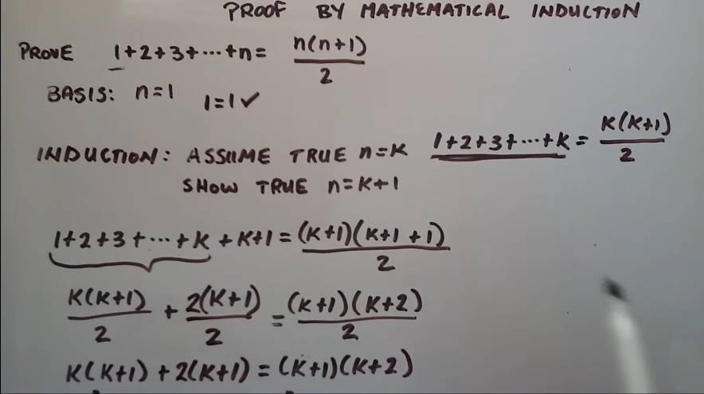

Just substitute the n = k to n = k + 1

If there is no other way just jump into ans for partial credit lol

**Inequality MIE** (prolly wont came out)

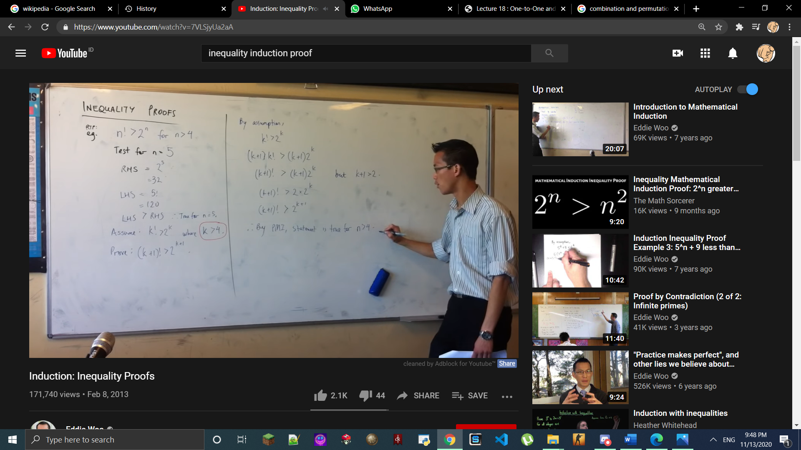

After n = k + 1 just substitute things to make the statement true

**Matrices and Linear Equation**

A system of linear equations has either

1. no solution

2. exactly one solution

3. infinitely many solutions

Find echelon (identity matrix) to solve the problem

Row operation to solve inverse

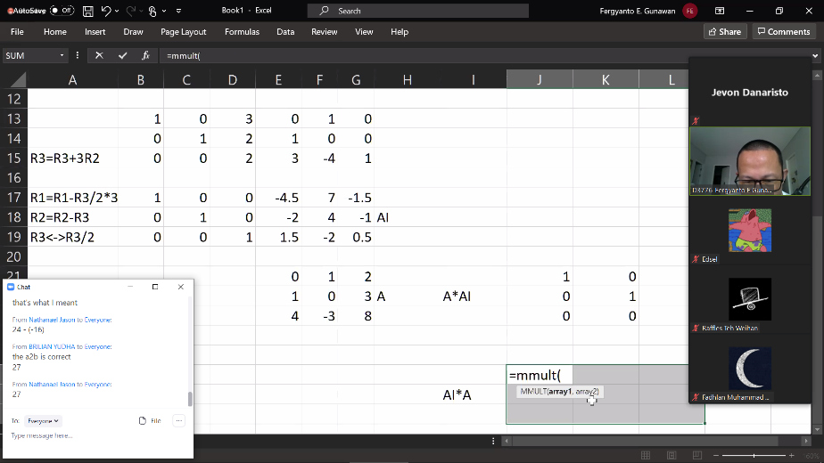

Use excel to do this, don’t make life harder

Check if the answer is right or not by using =mmult(questionmat,answermat) if it is right you will get identity

Find det using cofactor

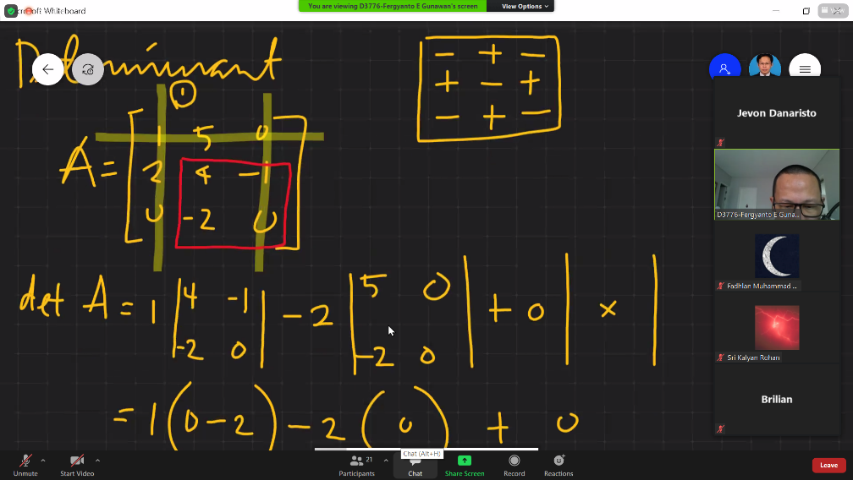

Make sure to use row with many 0 to ease your life

**PAY ATTENTION TO THE - + - PATTERN**

Use det to find x and y (Cramer’s rule)

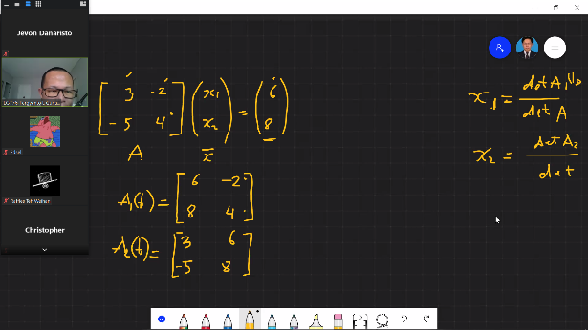

Find det of matrix

Find det if x is change

Find det if y is change

And ya got the ans

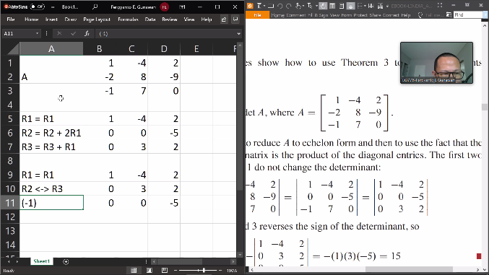

determinant characteristic when a row is changed

change row (det = -det)

row multiplication (det = x*det)

**Probability**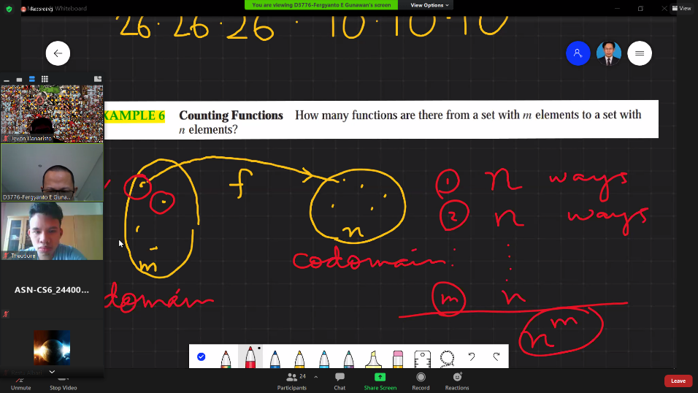

ie: 5 coin flipped at once

2 variant, 5 try

25

If there is question ask probability of x from x1<x2 it prolly 0

**Permutation and Combination**

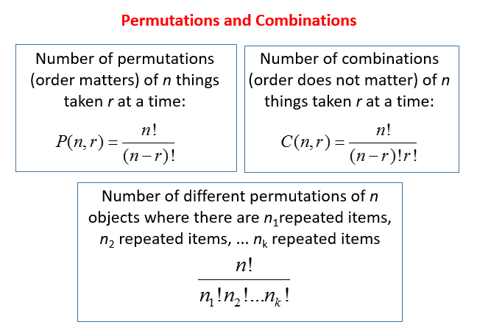

If ya don’t know what is n and r just remember n>r